Azure DevOps Build Pipeline

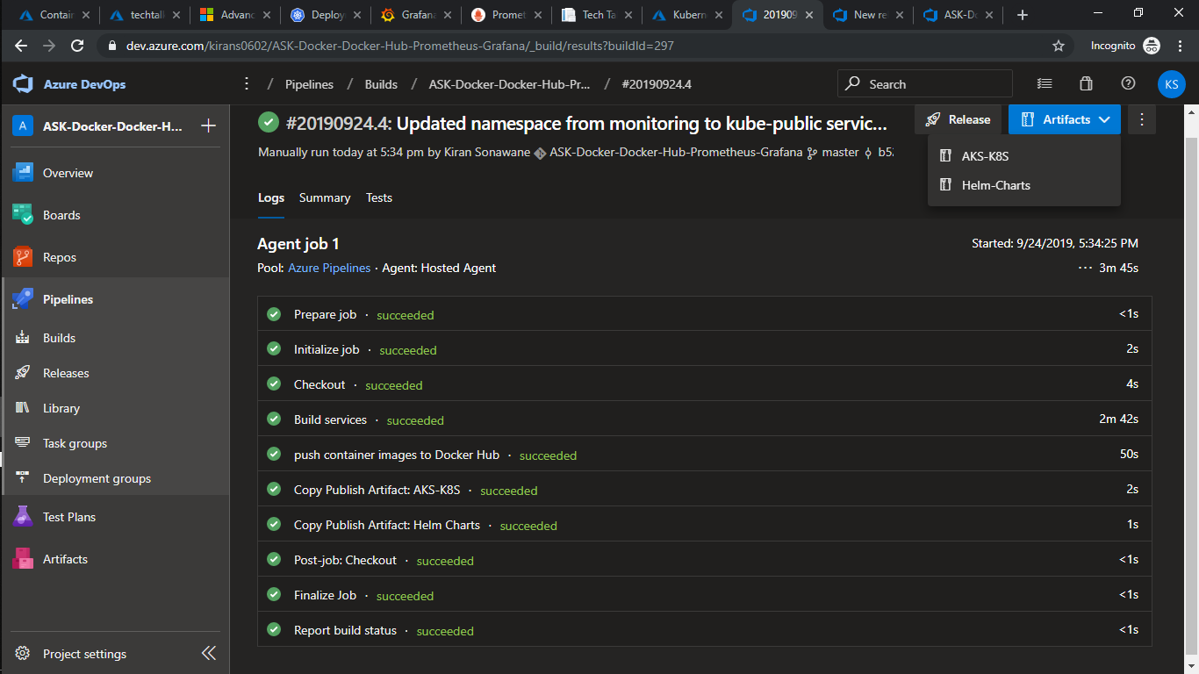

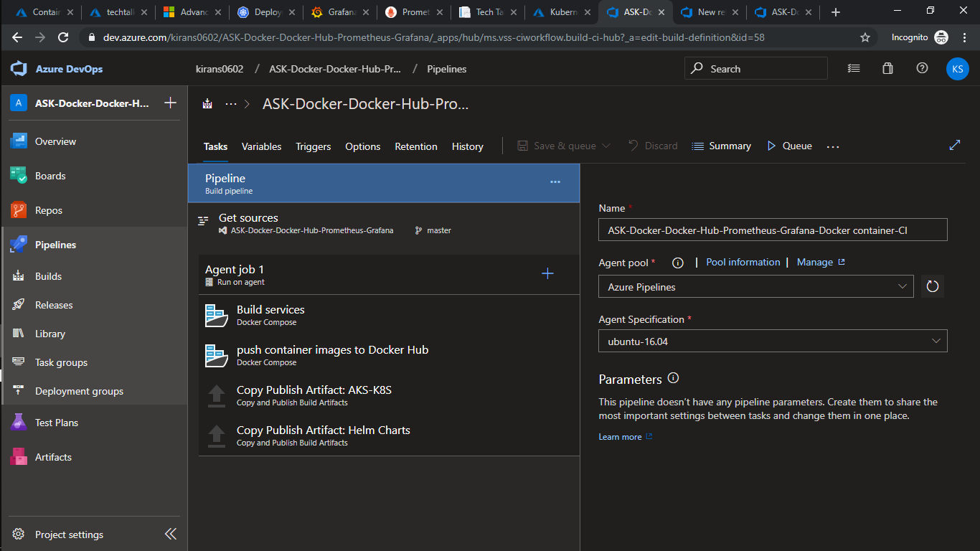

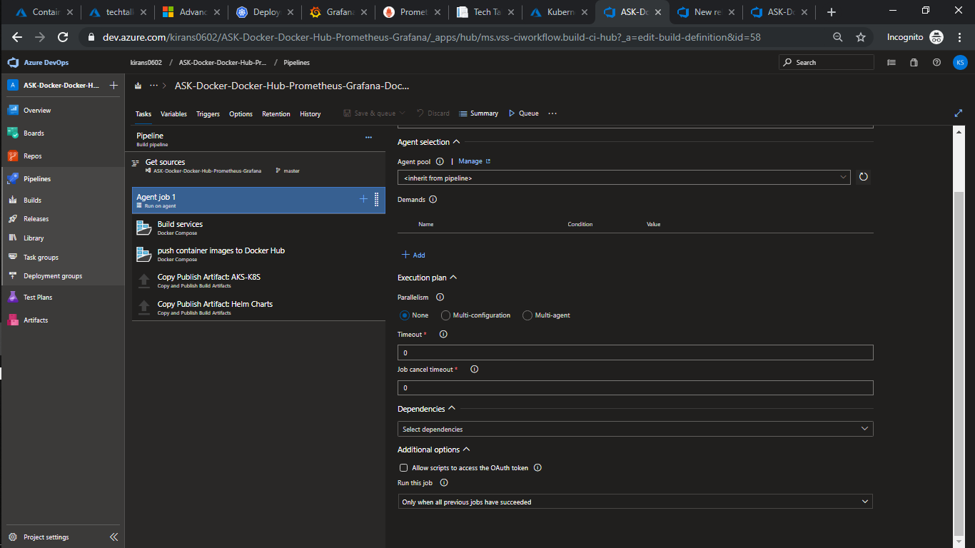

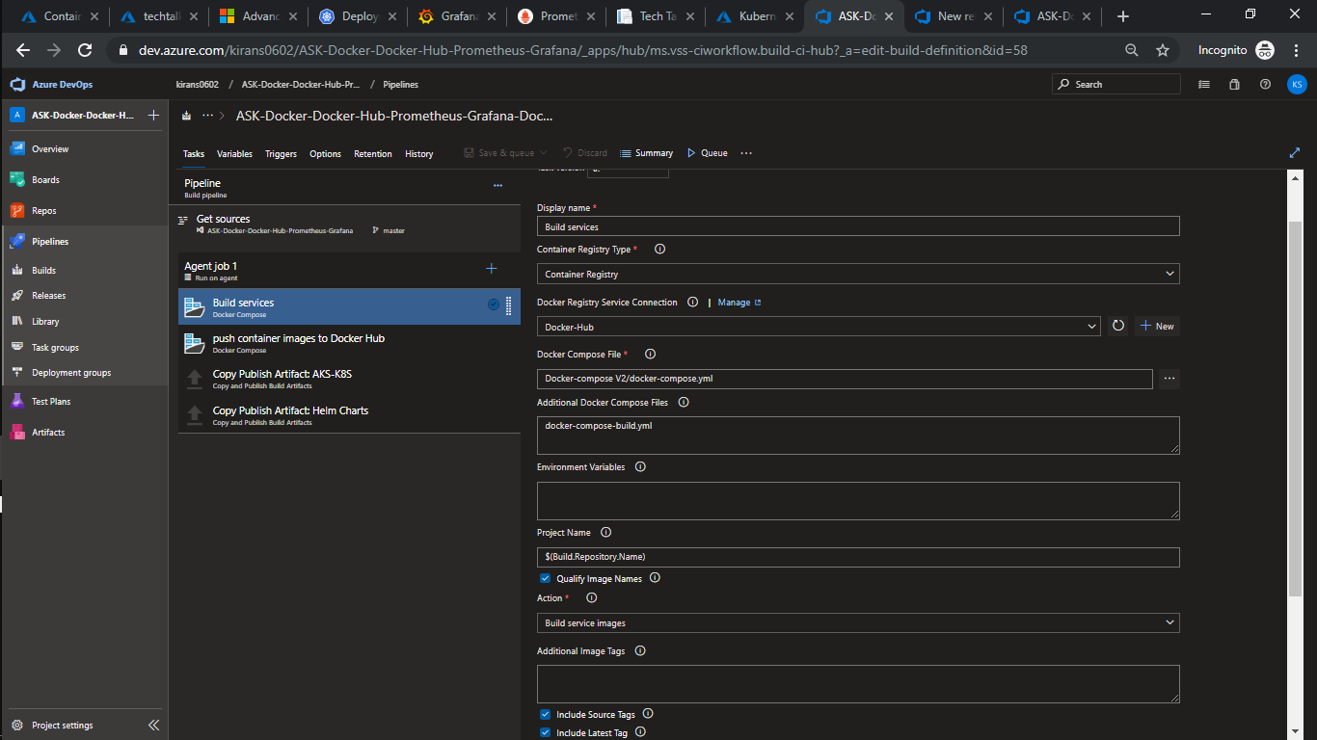

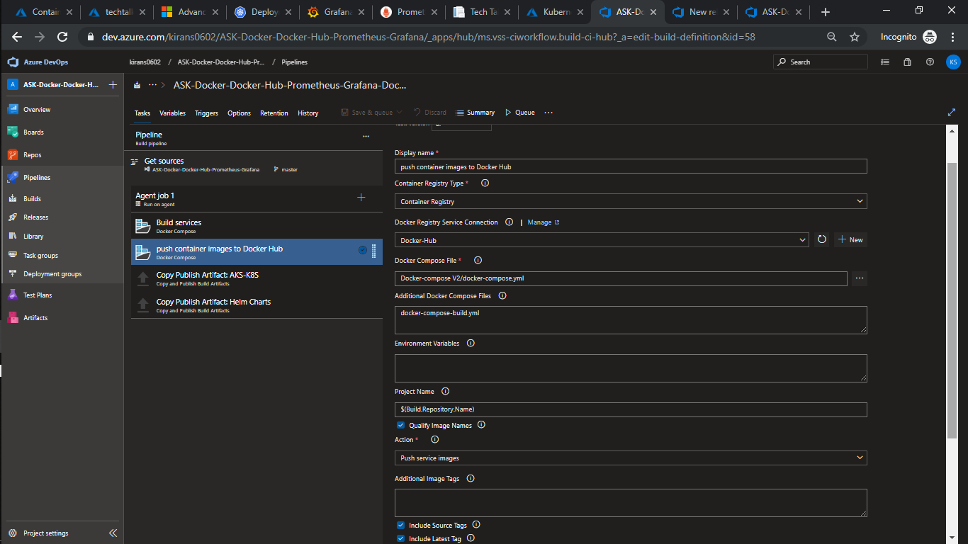

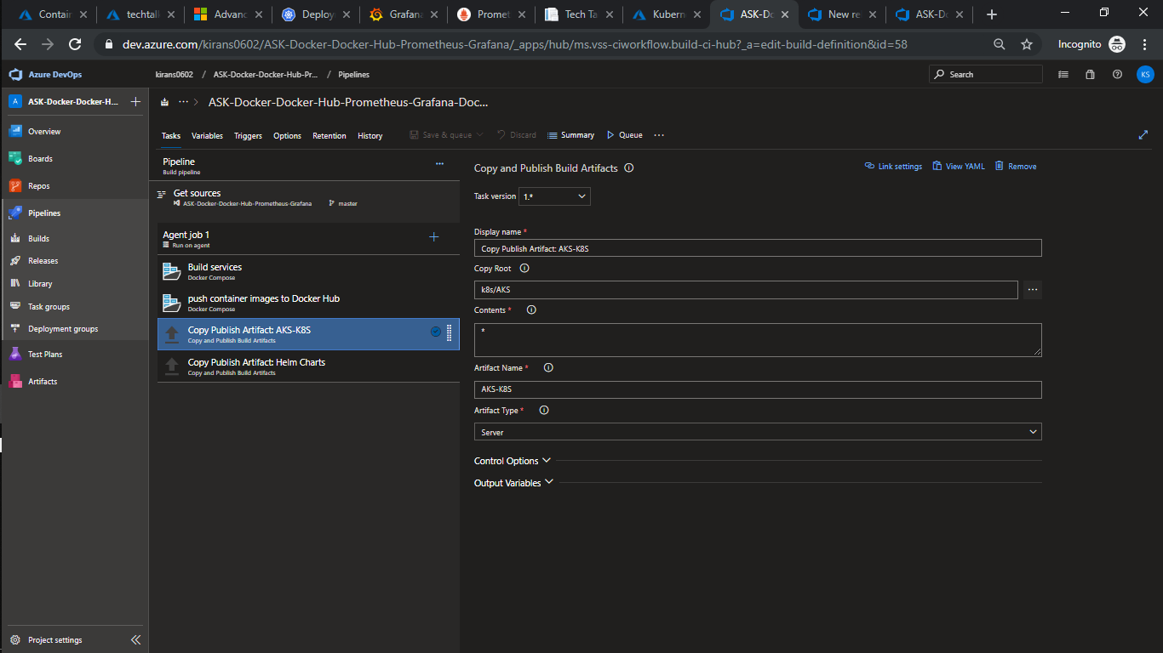

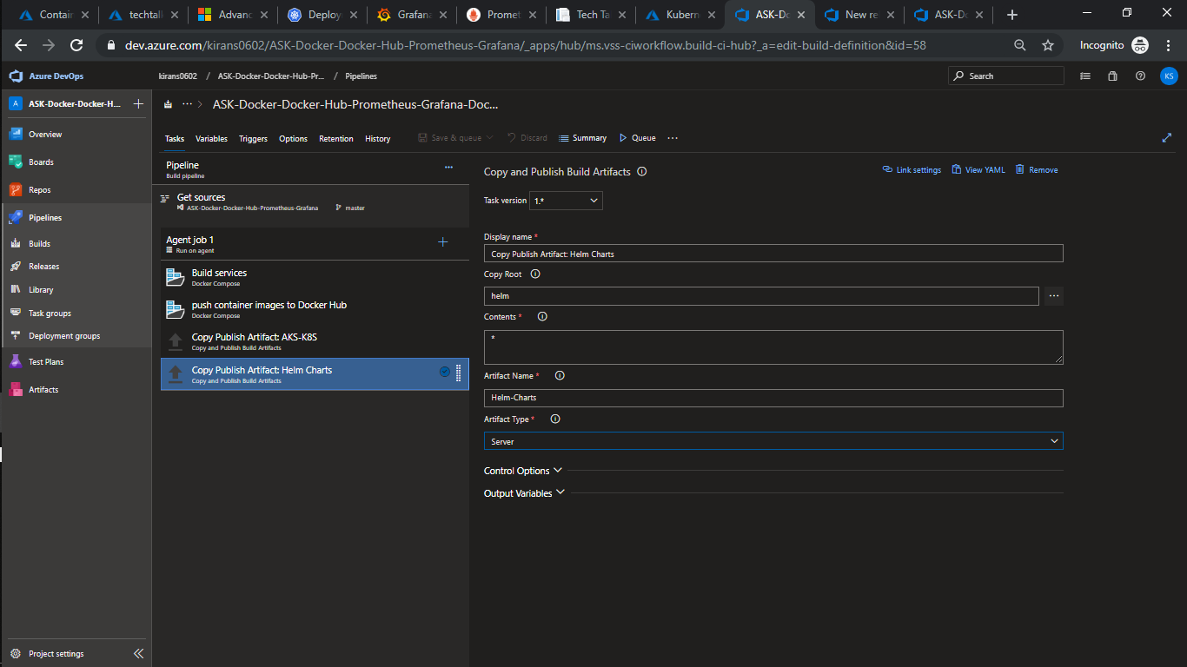

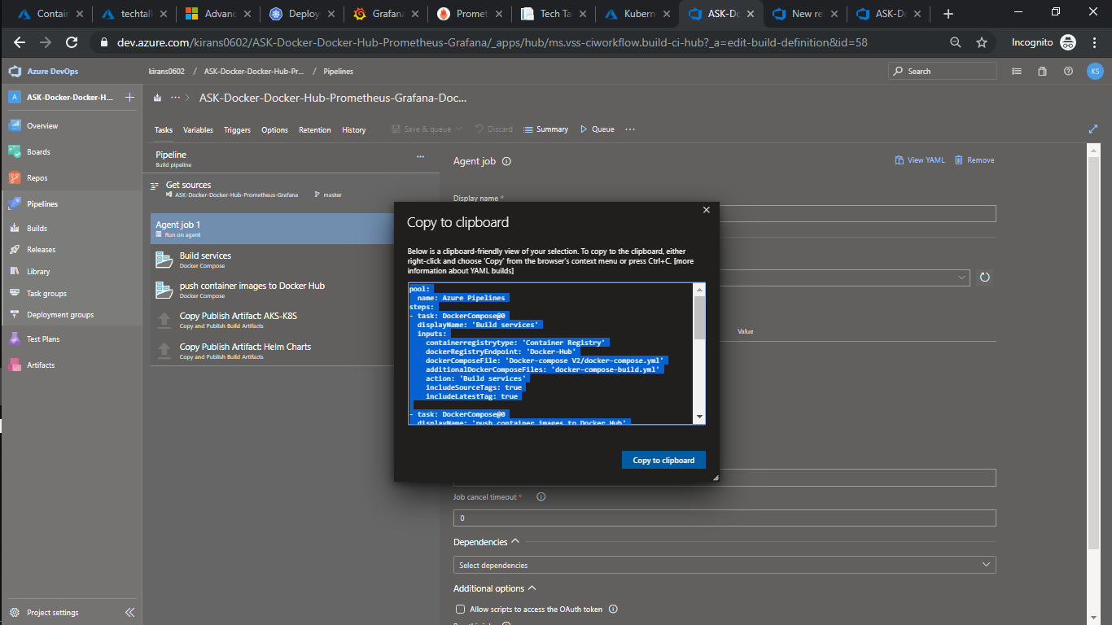

pool:

name: Azure Pipelines

steps:

- task: DockerCompose@0

displayName: 'Build services'

inputs:

containerregistrytype: 'Container Registry'

dockerRegistryEndpoint: 'Docker-Hub'

dockerComposeFile: 'Docker-compose V2/docker-compose.yml'

additionalDockerComposeFiles: 'docker-compose-build.yml'

action: 'Build services'

includeSourceTags: true

includeLatestTag: true

- task: DockerCompose@0

displayName: 'push container images to Docker Hub'

inputs:

containerregistrytype: 'Container Registry'

dockerRegistryEndpoint: 'Docker-Hub'

dockerComposeFile: 'Docker-compose V2/docker-compose.yml'

additionalDockerComposeFiles: 'docker-compose-build.yml'

action: 'Push services'

includeSourceTags: true

includeLatestTag: true

- task: CopyPublishBuildArtifacts@1

displayName: 'Copy Publish Artifact: AKS-K8S'

inputs:

CopyRoot: k8s/AKS

Contents: '\*'

ArtifactName: 'AKS-K8S'

ArtifactType: Container

- task: CopyPublishBuildArtifacts@1

displayName: 'Copy Publish Artifact: Helm Charts'

inputs:

CopyRoot: helm

Contents: '\*'

ArtifactName: 'Helm-Charts'

ArtifactType: Container